Name

Mathematics Stage 5 Paths
Angle Sums of Polygons

Book 1 |  | Version: 261007  Feedback:  https://MrDingMaths.com
Contents
Syllabus Content 2
Learning Intention 3

Syllabus Content
MA5-GEO-P-01 establishes conditions for congruent triangles and similar triangles and solves problems relating to properties of similar figures and plane shapes
Apply logical reasoning to numerical problems involving plane shapes
- Apply geometrical facts, properties and relationships to find the sizes of unknown sides and angles of plane shapes in diagrams, providing appropriate reasons
- Define the exterior angle of a convex polygon
- Establish the sum of the exterior angles of any convex polygon is $360°$ and verify this result
- Apply the result for the sum of the interior angles of a triangle to find, by dissection, the sum of the interior angles of a polygon with more than 3 sides
- Apply the results for the interior and exterior angles of polygons to solve problems involving polygons

Angle Sum of a Polygon

- Angle sum of a Polygon
- A polygon is a 2-dimensional shape with at least three straight sides and angles.
- The number of interior angles is equal to the number of sides.
Polygon | Sides | Triangles | Angle Sum
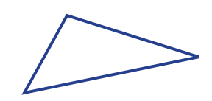  Triangle | 3 | 1 | $1×180°=180°$
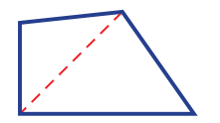  Quadrilateral | 2 | 2 | ……… $×180°=$ ………
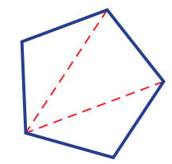
Pentagon

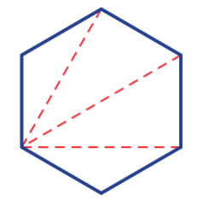
Hexagon


Heptagon


Octagon

$n$-gon |  |  | ……… $×180°$

- Interior Angle Sum of a Polygon
The interior angle sum of a polygon with $n$ sides is:
$$S=180\left(n-2\right)$$

- Example Use the formula for the angle sum of a polygon
Find the angle sum of a heptagon.
$S=180\left(n-2\right)$
$=180\left(7-2\right)$
$=180(5)$
$=900°$

- Guided Practice
Find the angle sum of a:
- Hexagon  720° | - Decagon (10 sides)  1440°

- Key Ideas
- The interior angle sum of any polygon is given by the formula ………………………

Foundation
- Find the interior angle sum of these polygons.
- Octagon (8 sides)  1080° | - nonagon (9 sides)  1260° | - heptagon (7 sides)  900°
- 11-sided polygon  1620° | - 15-sided polygon  2340° | - 45-sided polygon  7740°

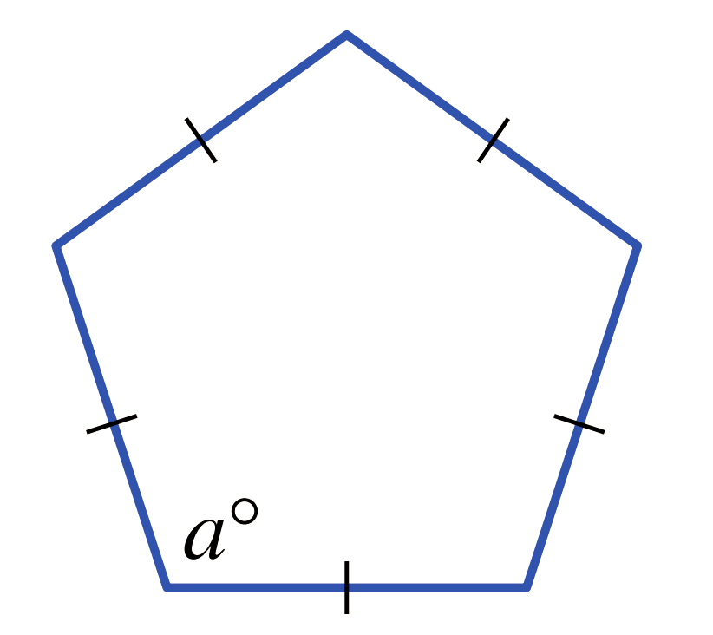
- Regular polygons have equal interior angles.
  - What is the angle sum of a pentagon?

540°
  - What is the size of each interior angle of a pentagon?

108°
- Find the size of an interior angle for these regular polygons with the given angle sum.
- regular octagon (1080°)  135° | - regular nonagon (1260°)  140° | - regular decagon (1440°)  144°

- Find the size of each interior angle of these regular polygons.
Round the answer to one decimal place where necessary.
- regular hexagon  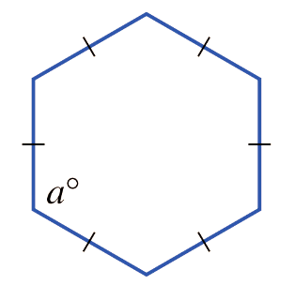  120° | - regular heptagon  128.6° | - regular 32-sided polygon  168.8°

Development
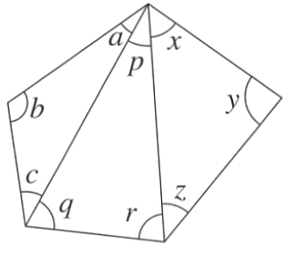
- Use the diagram and angle sum of a triangle to explain why the sum of the interior angles of a pentagon is 540°.
$a+b+c=$ ………$°$ ( ……………………………… )
180° ($∠$ sum of $Δ)$
$p+q+r=$ ………$°$ ( ……………………………… )
180° ($∠$ sum of $Δ)$
$x+y+z=$ ………$°$ ( ……………………………… )
180° ($∠$ sum of $Δ)$
$∴(a+b+c)+(p+q+r)+(x+y+z)=$ ………$°$
540°
Therefore, the interior angle sum of a pentagon is ………$°$
540°

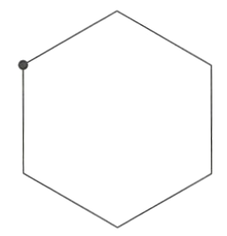
  - Split the hexagon into triangles by drawing diagonals from the indicated vertex.
  - How many triangles are formed inside the hexagon?
4
  - Work out the sum of the interior angles of a hexagon.
720°

- Find the number of sides of a polygon with the given angle sums.
- 1260°  $S=180(n-2)$  $1260=180(n-2)$  9 | - 2340°  15 | - 3420°  21
- $720°$  6 | - $3240°$  20 | - $1260°$  9

- The angle sum of a regular polygon is $2520°$
- How many sides does it have?  16 | - Find the size of each angle.  157.5°

Mastery
- Let $S$ be the angle sum of a regular polygon with $n$ sides.
  - Write the rule for the size of an interior angle in terms of $S$ and $n$.
Each interior angle = S ÷ n
  - Write a rule for the size of an interior angle in terms of $n$ only.
Substitute S = 180(n - 2):
Each interior angle = $180(n - 2) ÷ n$
Or simplified: $180 -$ $\frac{360}{n}$
  - Use your rule to find the size of an interior angle of these polygons.
Round to two decimal places where appropriate.
    - regular dodecagon ………………… ii 82-sided regular polygon …………………
150° 175.61° (to 2 d.p.)
- Given that each interior angle of a regular polygon is $I=$ $\frac{180(n-2)}{n}$,
rearrange the formula so that $n$ is the subject.

$$n = -\frac{360}{\left(I - 180\right)}$$
- Find the number of sides of a regular polygon if each interior angle is:
- $150°$  12 | - $175°$  72 | - $162°$  20
- $140°$  9 | - $165.6°$  25 | - 147.272727…°  11

- Consider a regular polygon with a very large number of sides ($n$).
  - What shape does this polygon look like?
circle
  - Is there a limit to the size of a polygon angle sum as $n$ increases?
Using S = 180(n - 2), as $n$ gets larger, $S$ keeps growing without bound.
  - What size does each interior angle approach as $n$ increases?
Each interior angle = $180\left(n - 2\right)÷ n = 180 -$ $\frac{360}{n}$
As $n$ increases, $\frac{360}{n}$ approaches 0, so each interior angle approaches 180°.

- Is it possible for a regular polygon to have interior angles of size $132°$?
Explain why or why not.
Using the formula: $n =$ $\frac{360}{\left(180-I\right)}$
$$For I = 132°, n = 7.5$$
$∴$ no

Problems Involving Angle Sum of a Polygon

- Interior Angle Sum of a Polygon
- If a problem involves finding a missing angle inside a polygon:
- Determine the angle sum using $S=180\left(n-2\right)$.
- Form an equation to find the missing angle.

- Example Solve problems involving angle sum of a polygon
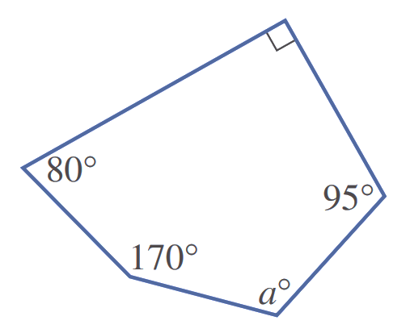
Find the value of $a$ in this pentagon.
1. Angle sum
$S=180\left(n-2\right)$
$=180(5-2)$
$=540°$
2. Form an equation
$a+170+80+90+95=540$
$a+435=540$
$a=105$

- Guided Practice
Find the missing angle.
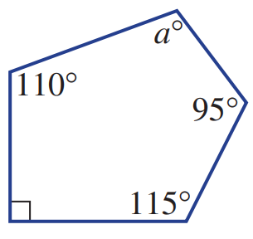  1. Angle sum  $S=180\left(n-2\right)$  2. Form an equation  130° | 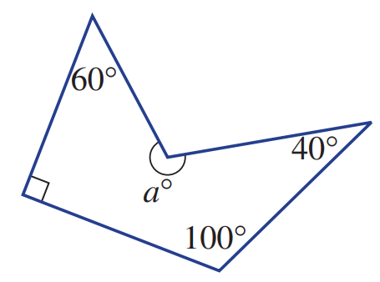  250°

Foundation
- Find the value of $a$ in these polygons. Remember to find the angle sum first.
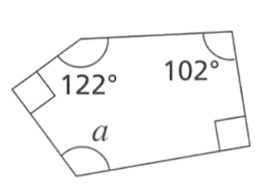  $$S=180(n-2)$$  136° | 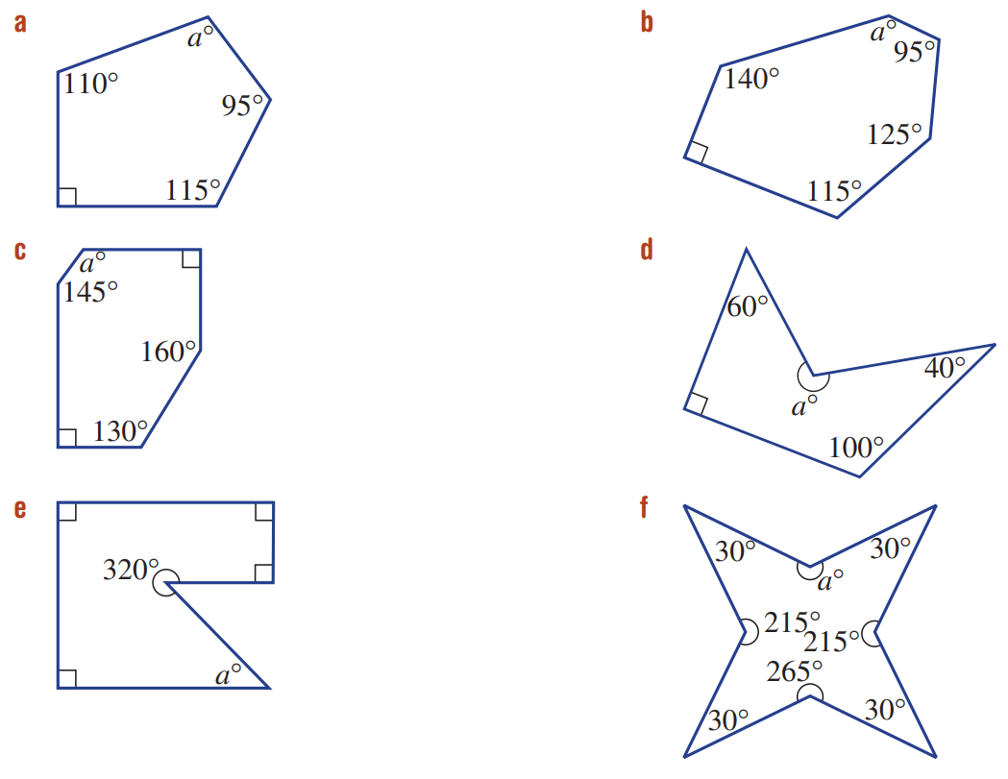  155 | 105
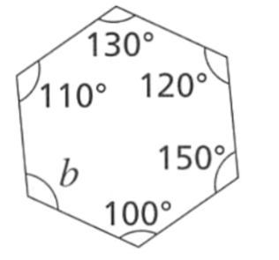  110° | 40 | 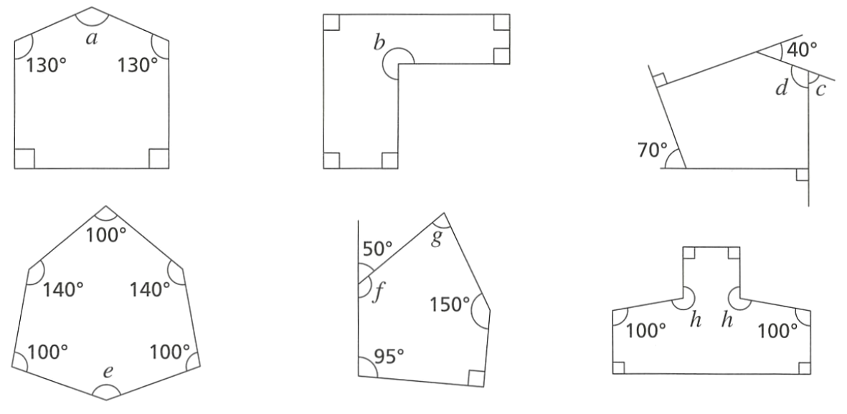  140°

- Find the value of the pronumeral in these diagrams.
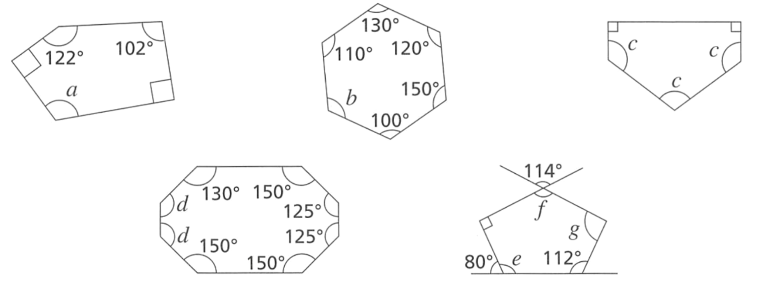  120° | 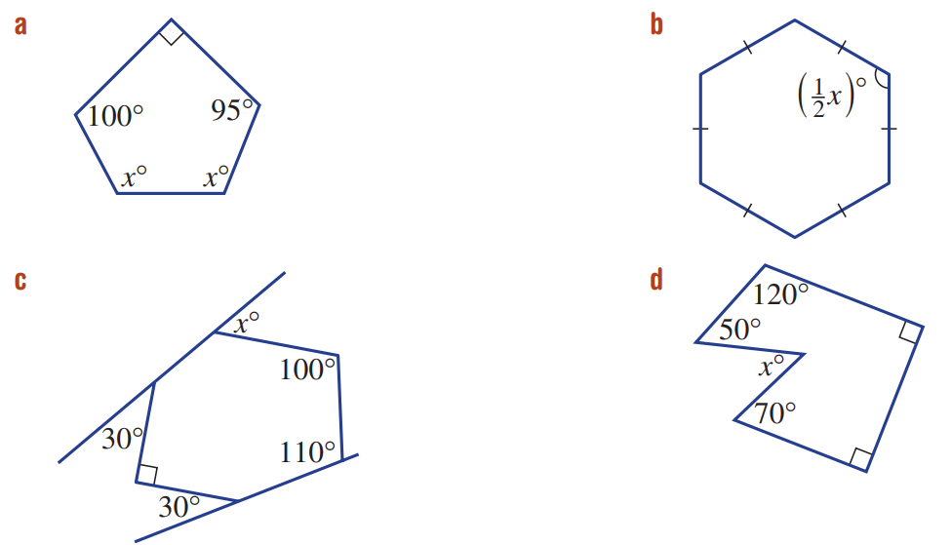  127.5 | 125°
260° | 240 | 60

Development
- Find the value of the pronumeral in these diagrams.
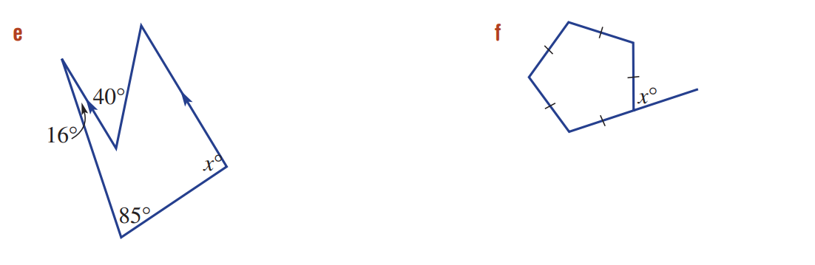  72 | $$f=130°, g=75°$$ | 60
$$c=70°, d=110°$$ | 79 | 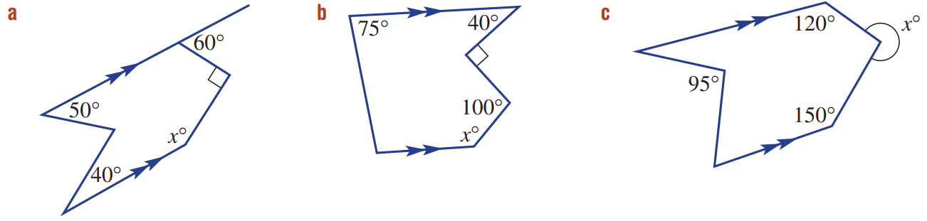  150
130 | 270

- Find the value of $x$ in these diagrams.
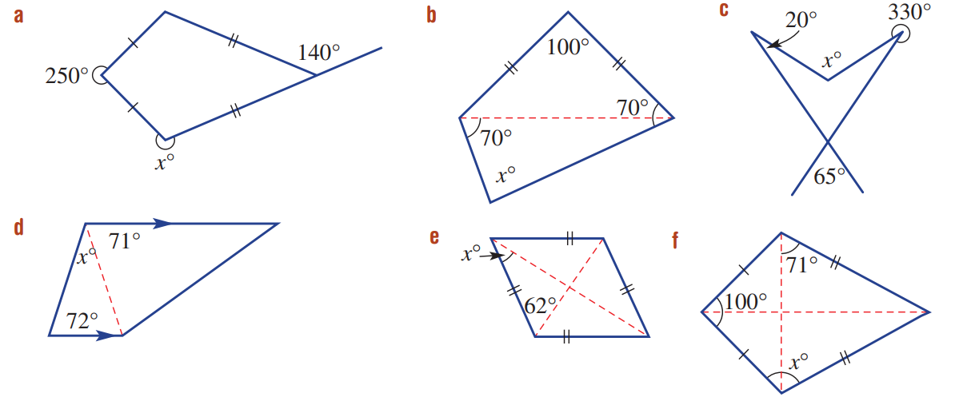  255 | 80 | 115
37 | 28 | 111

- The diagram shows a regular hexagon ABCDEF. The line AC is constructed.
Work out the size of angle $x$.
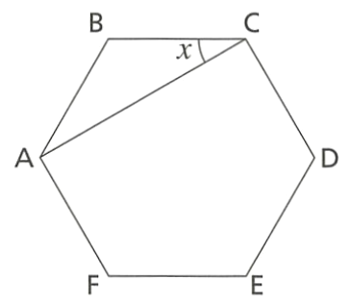

$ΔABC$ is isosceles (two equal sides)
$∠B=120°$ (interior angle of a hexagon)
$x+x+120=180$ (angle sum of triangle)
$$∴x=30°$$

Mastery
- Work out the value of the pronumeral, given that these are regular polygons.
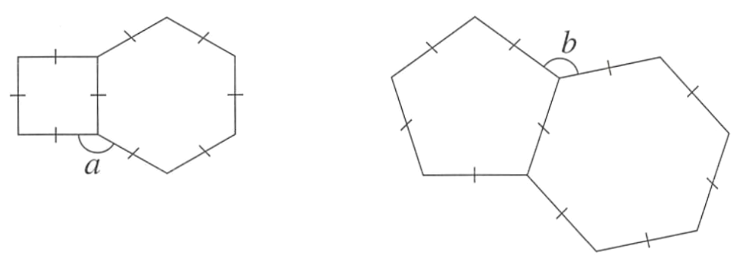  150° | 132°

- Work out the value of $a$
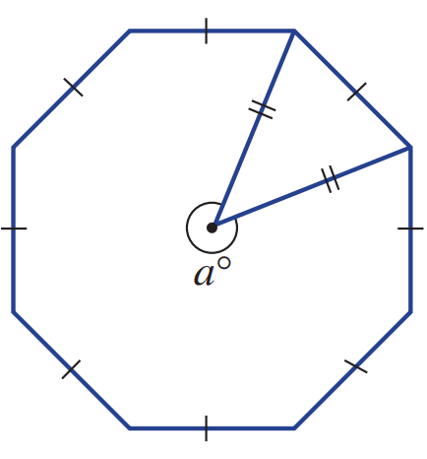

Let $θ$ be the angle inside the triangle at the centre of the octagon.
$$θ=360÷8=45°$$
$x=360-45°=315°$
- Prove that $∠ABC=90°$
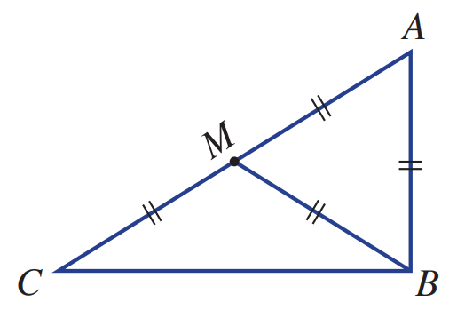

∠AMB = 60° (△ ABM is equilateral).
∠BMC = 120° (supplementary).
Therefore, ∠MBC = 30° (△ MBC is isosceles).
So ∠ABC = ∠ABM + ∠MBC = 60°+ 30°= 90°
- A framework for a symmetrical roof is shown. AD is perpendicular to BC.
Find the value of the angles marked $p,q,r$.
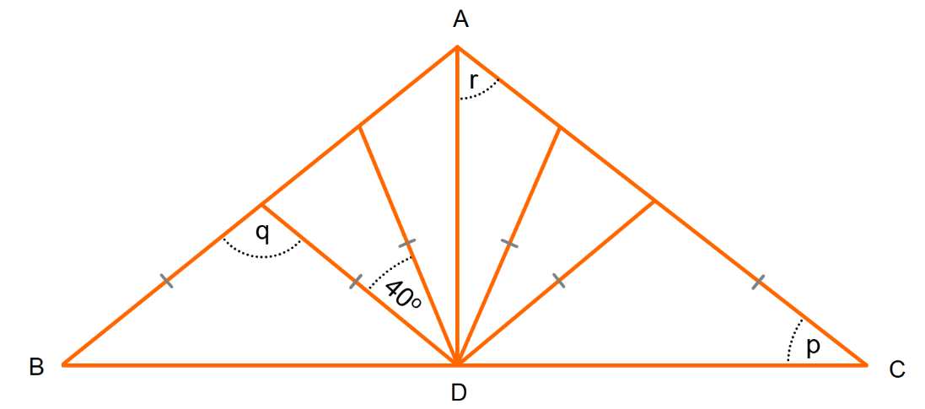

$$q=110°$$
$$p=35°$$
$$r=55°$$
- ABCDE is a regular pentagon. Work out the value of $x$.
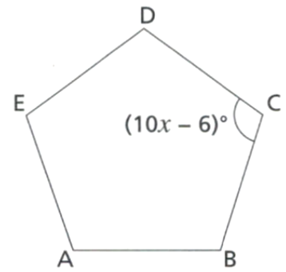

$5\left(10x-6\right)=540$ (angle sum of pentagon)
$x=$ 11.4°
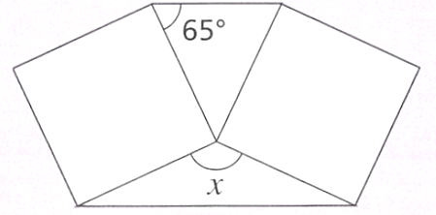
- The diagram shows two identical squares. Find the size of angle $x$.

Let $θ$ be the angle opposite $x$.
Angle sum at a point: $x+90+90+θ=360°$
$θ=180-2\left(65\right)=50°$ (angles in isosceles triangle)
$∴x=$ 130°
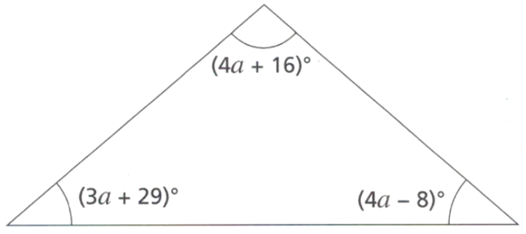
- Show that this triangle is isosceles.

Sum of all angles: 11a + 37 = 180°
a = 13°
Sub into the expressions for the angles gives 44°, 68°, 68°.
Since two angles are equal, it must be an isosceles triangle.
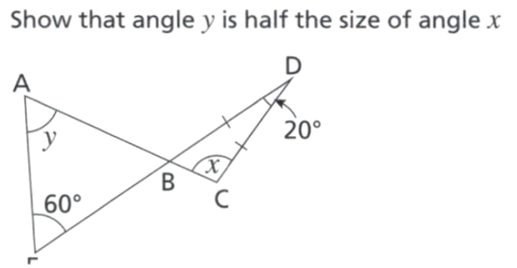
- Show that angle $y$ is half the size of angle $x$.
E

$∠$DCB = $∠$DBC = 80° (angles in a triangle add up to 180°; two angles in an isosceles triangle are equal)
$∠$ABE = 80° (vertically opposite angles are equal)
$∠$BAE = 40° (angles in a triangle add up to 180°)
40° is half of 80°, as required
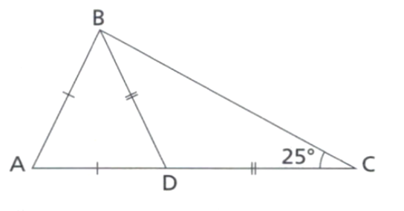
- Show that $∠BAD=80°$. Give a reason for each stage of your working.
$∠$DBC = 25° (two angles in an isosceles triangle are equal)
$∠$BDC = 130° (angles in a triangle add up to 180°)
$∠$ADB = 50° (angles on a straight line add up to 180°)
$∠$DBA = 50° (two angles in an isosceles triangle are equal)
$∠$BAD = 80° (angles in a triangle add up to 180°)

- Show that this shape is a right-angled triangle.
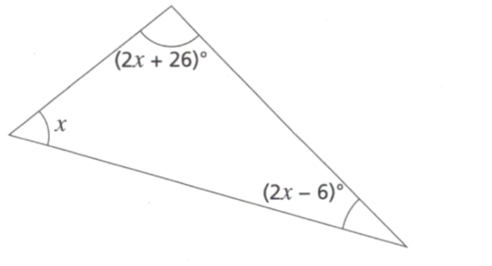

Angles in a triangle add up to 180°
$$5x + 20° = 180°,x = 32°$$
The angles are then 32°, 58° and 90°
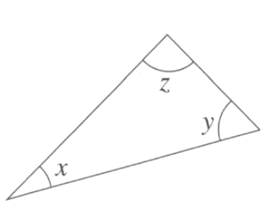
- Consider the triangle.
  - If $x+y=z$, show that $z$ must equal $90°$

$x+y+z=180°$ (angle sum of triangle)
$$∴z+z=180°$$
$$∴z=90°$$
  - If $x+y=2z$, show that $z$ must be equal to $60°$
$x+y+z=180°$ (angle sum of triangle)
$$2z+z=180°$$
$$z=60°$$

- Show that this shape is a parallelogram. Clearly justify your answer.
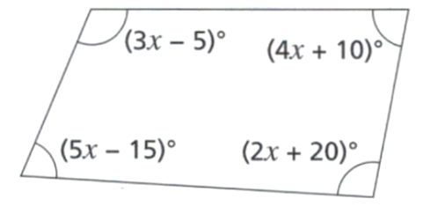

Angle sum of quadrilateral: $14x+10=360°$
$$x=25°$$
Substituting into expressions for angles, 70, 110, 70, 110
Co-interior angles sum to 180°, so opposite sides are parallel.

- Show that $p+q=r+s$
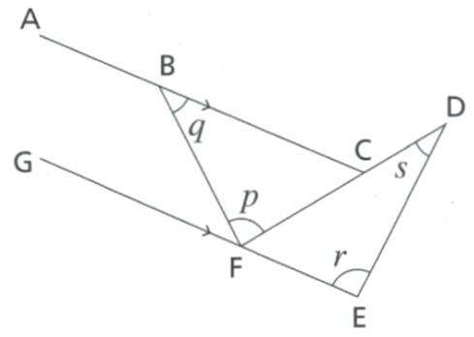

$∠BFG = q$ (alternate angles are equal)
$∠$DFE = $180° - (r + s)$ (angles in a triangle add up to 180°)
On a straight line at F: $q + p + 180 -(r + s) = 180°;$
Hence $q + p = r + s$

Exterior Angle Sum of a Polygon

- Exterior Angle Sum of a Polygon
- When we extend one side of a polygon, it forms an exterior angle.
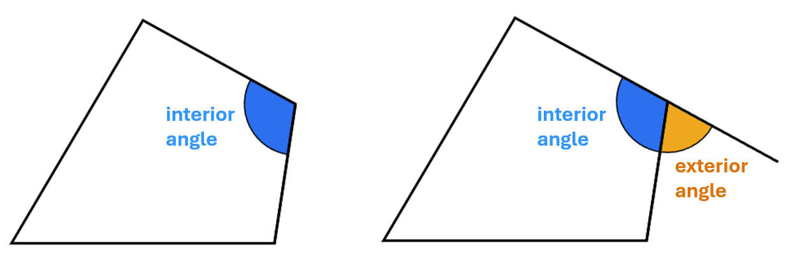

- The sum of an interior angle and its exterior angle is $180°$ (supplementary).

- Sum of exterior angles of a polygon
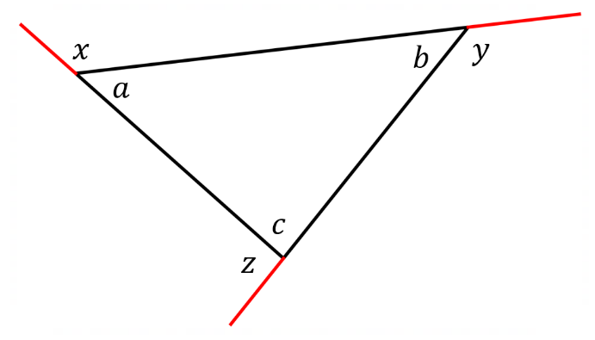
Consider this triangle.
$a+x=$ ……………
$b+y=$ ……………
$c+z=$ ……………

The sum of all the interior and exterior angles is:
$\left(a+x\right)+\left(b+y\right)+\left(c+z\right)=$ $3×180$
$=$ …………
The sum of interior angles is:
$a+b+c=$ ……………
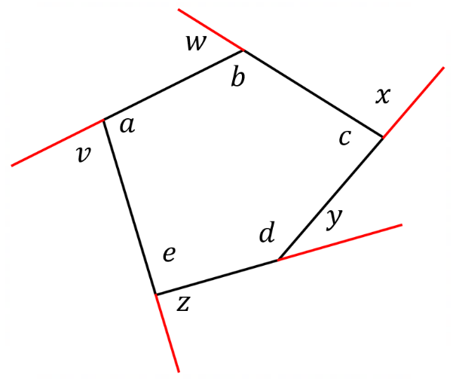
So, the sum of exterior angles is:
$x+y+z=$ $540-$ …………
$=$ ……………

Consider this pentagon.
$a+v=$ ……………
$b+w=$ ……………

The sum of all the interior and exterior angles is:
$\left(a+v\right)+\left(b+w\right)+\left(c+x\right)++y)+\left(e+z\right)=$ ……………

The sum of interior angles is:
$a+b+c+d+e=$ ……………
So, the sum of exterior angles is:
$v+w+x+y+z=$ ……………
- Exterior Angle Sum of a Polygon
- Exterior angle sum https://www.geogebra.org/m/jgpwcukv
https://www.geogebra.org/m/fnkpeucj

- The exterior angle sum of any polygon is $360°$
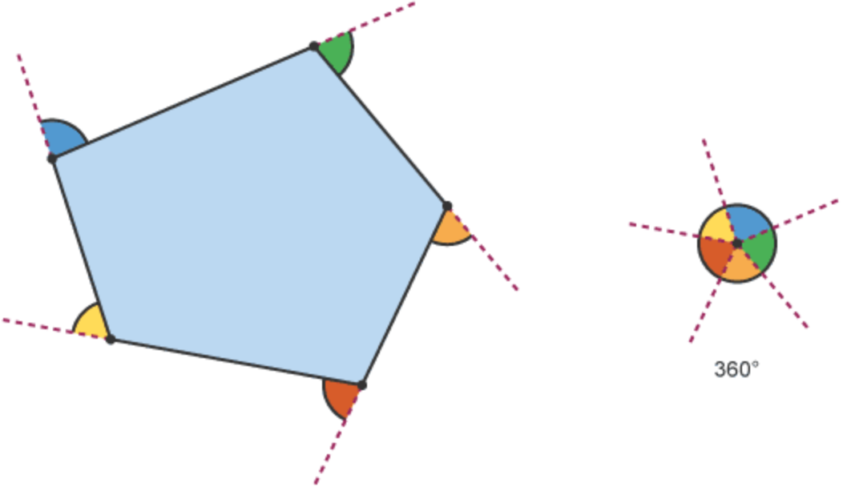

- The exterior angle of a regular polygon with $n$ sides:
$$E=\frac{360°}{n}$$

- Example Solve problems involving exterior angles of a polygon
Find the size of each exterior angle of a regular decagon.  $$E=\frac{360°}{10}=36°$$ | Each exterior angle of a regular polygon is $12°$  How many sides does it have?  $$12°=\frac{360°}{n}$$  $$n=\frac{360°}{12°}=30$$

- Guided Practice
- Find the size of each exterior angle of a regular octagon.  45° | - Find the size of each exterior angle of a regular 20-sided polygon.  18°
- Each exterior angle of a regular polygon is 15°. Find the number of sides of the polygon.  24 sides | - Find the number of sides in a regular polygon with each exterior angle $10°$  36 sides

- Key Ideas
- The exterior angle sum of any polygon is …………………

Foundation
- In which diagram is $x$ an exterior angle?
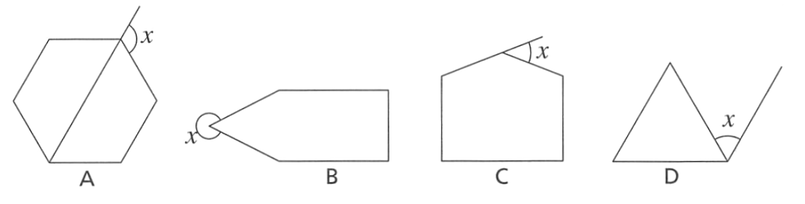

C
- Work out the sizes of the exterior angles of each of these shapes.
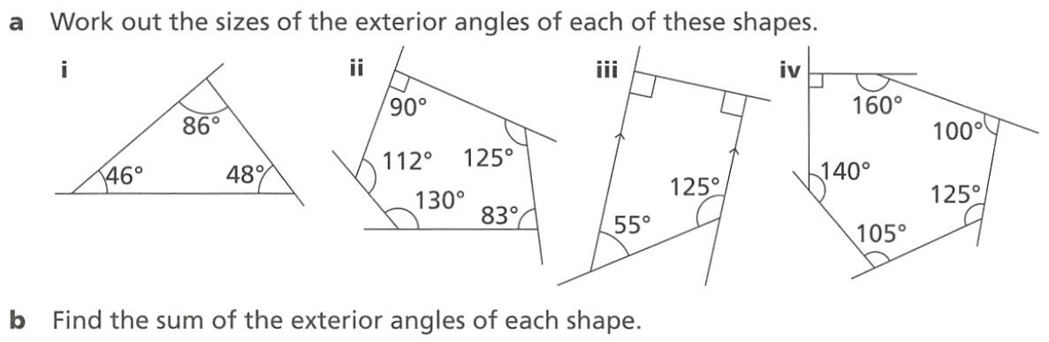  94°,132°, 134° | 90°, 55°, 97°, 50°, 68° | 90°, 90°, 55°, 125°
What is the sum of the exterior angles for each of the shapes above?
360°
- Find the size of each exterior angle in a regular:
- Pentagon  72° | - Dodecagon  30° | - 18-sided polygon  20°

- Each exterior angle of a regular polygon is 15°. Find the number of sides of the polygon.  24 sides | - Find the number of sides in a regular polygon with each exterior angle of 18°  20 sides

  - Explain why each exterior angle of a regular hexagon is $60°$
In a regular hexagon, all exterior angles are equal, so each exterior angle = 360° ÷ 6 = 60°.
  - Work out the size of each exterior angle of a:
    - Regular pentagon
72°
    - Regular heptagon
51.43°
    - Regular 30-sided polygon.
12°
  - What happens to the size of each exterior angle as the number of sides of a regular polygon increases?
The exterior angle approaches 0°.

Development
- Find the number of sides of a regular polygon if each exterior angle is:
- $24°$  15 | - $36°$  10 | - $5°$  72

- A 50-cent piece has 12 equal sides and 12 equal angles. Calculate the size of each:
- exterior angle  30° | - interior angle  150°

  - Find the size of each exterior angle of a regular octagon.
45°
  - Use the exterior angle to find the size of the interior angle. Give a reason for the answer.

135°. The interior and exterior angles at each vertex are supplementary (they sum to 180°), so I = 180° - E.
  - Hence, find the angle sum of an octagon.
$$S = (8 - 2) × 180° = 6 × 180° = 1080°$$

  - Find the size of each exterior angle of a regular 14-sided polygon.

E = 360° ÷ 14 = 25.71°
  - Find the size of each interior angle.
I = (14 - 2) × 180° ÷ 14 = 154.29°

- Determine the sizes of the labelled angles in these diagrams.
$$a=140°$$ | $$b=53°, c=127°$$ | 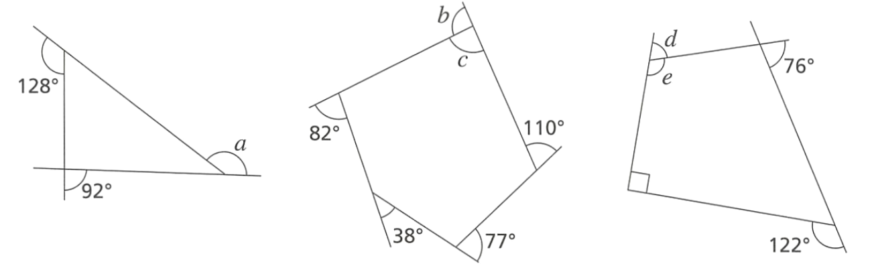  $$d=72°, e=108°$$

Mastery
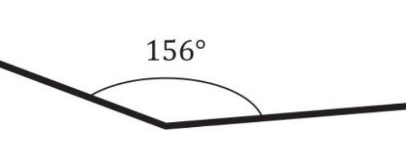
- A regular polygon has a single interior angle as shown.
Work out the number of sides of the regular polygon
Exterior angle is $24°$
$$n=\frac{360}{24}=15$$
15 sides
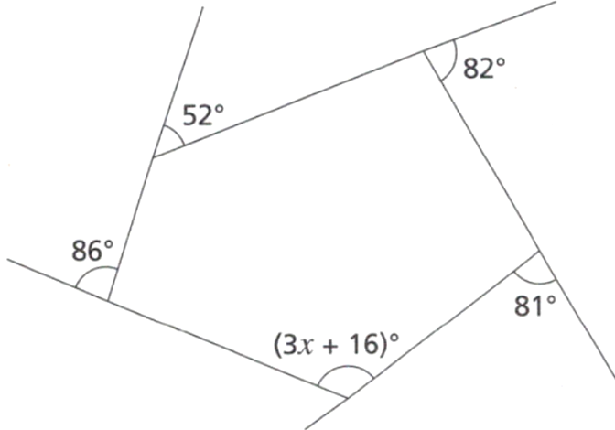
- Work out the value of $x$

Exterior angle of $\left(3x+16\right)$ is $59°$
$$3x+16+59=180$$
$$x=35°$$
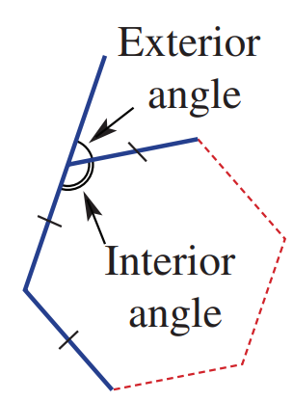
- For a regular polygon with $n$ sides:
  - write the rule for the sum of interior angles ($S$)
$$S = 180(n - 2)$$
  - write the rule for the size of each interior angle ($I$)
$$I = \frac{180(n-2)}{n}$$
  - write the rule for the size of each exterior angle ($E$)
$$E=\frac{360}{n}$$
  - use your rule from part c to find the size of the exterior angle of a regular decagon.
$$E = \frac{360°}{10} = 36°$$
- If you follow the path around this pentagon clockwise starting and finishing at point A, you will have turned a total of 360°. Complete this proof of the angle sum of a pentagon (540°).
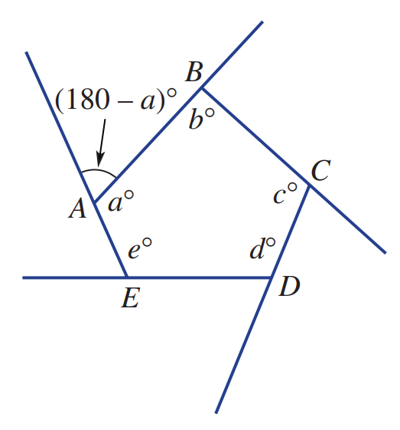
$\left(180-a\right)+\left(180-b\right)+$ ………… $+$ ………… $+$ ………… $=$ ………
$\left(180-c\right) + \left(180-d\right) + \left(180-e\right) = 360$
(sum of exterior angles is …………)
360°
$180+180+$ …… $+$ …… $+$ …… $-$ $(a+b$ $+$ …… $+$ ……$)$ $=360°$
180 180 180
……………… $-$ (………………………) $=360°$
900 – $a+b+c+d+e$
(………………………) $=$ ……°
$a+b+c+d+e$ 540°
- An irregular polygon has one exterior angle of 100° and all others are 13°.
  - Explain why the sum of all the $13°$ angles is $260°$
360° - 100° = 260°
  - Therefore, how many 13-degree angles are there?
260° ÷ 13° = 20 angles of 13°
  - How many sides are there, in total? (hint: it’s not 20)
21 sides in total.
  - To find the number of sides, we can use the equation $100+13(n-1)=360°$,
where $n$ is the number of sides in the polygon. Explain why.

There's one 100° angle and $(n - 1)$ angles of 13°, where $n$ is the total number of sides.
  - Find the number of sides of the polygon using the equation.
$$100 + 13(n - 1) = 360$$
$$13(n - 1) = 260$$
$$n - 1 = 20$$
$n = 21$sides

- Find the number of sides in an irregular polygon with one exterior angle of 60° and all others 10°
$$60 + 10(n - 1) = 360$$
$$10(n - 1) = 300$$
$$n - 1 = 30$$
$n = 31$ sides

- Find the number of sides in an irregular polygon with one exterior angle of 45° and all others 15°

$$45 + 15(n - 1) = 360$$
$$15(n - 1) = 315$$
$$n - 1 = 21$$
$n = 22$sides

- An irregular polygon has two exterior angles twice the size of the others.
If the other exterior angles are 15°, find the number of sides.
$$2(30) + 15(n - 2) = 360$$
$$60 + 15(n - 2) = 360$$
$$15(n - 2) = 300$$
$$n - 2 = 20$$
$n = 22$ sides

- An irregular polygon has two exterior angles twice the size of the others.
If the other exterior angles are 20°, find the number of sides.

$$2(40) + 20(n - 2) = 360$$
$$80 + 20(n - 2) = 360$$
$$20(n - 2) = 280$$
$$n - 2 = 14$$
$n = 16$ sides
- Four of the exterior angles of a pentagon are 90°, 60°, 70° and 90°
Work out the interior angles of the pentagon.

Four exterior angles are 90°, 60°, 70° and 90°.
Sum of these four: 90 + 60 + 70 + 90 = 310°
The fifth exterior angle: 360° - 310° = 50°

Each interior angle is supplementary to its exterior angle:
Interior angles: 90°, 120°, 110°, 90°, 130°
- Is it possible for the exterior angle of a regular polygon to be 150°? Why or why not?

If each exterior angle is $150°:$
$$150 =\frac{360}{n}$$
$$n =\frac{360}{150} = 2.4$$
Since a polygon must have a whole number of sides, an exterior angle of 150° is impossible for a regular polygon.

- A regular polygon has exterior angles and interior angles in the ratio 2:7.
How many sides does it have?
E : I = 2 : 7
$$\frac{E}{I}=\frac{2}{7}$$
$$∴I=3.5E$$

$$E+I=180$$
$$E+3.5E=180$$
$$∴E=40°$$

Using $E =$ $\frac{360°}{n}$
$n = \frac{360}{40}= 9$ sides

